Go To:

<http://education.ti.com/en/us/products/computer_software/ti-smartview-software/ti-smartview-emulator-software-for-the-ti-84-plus-family/tabs/overview>

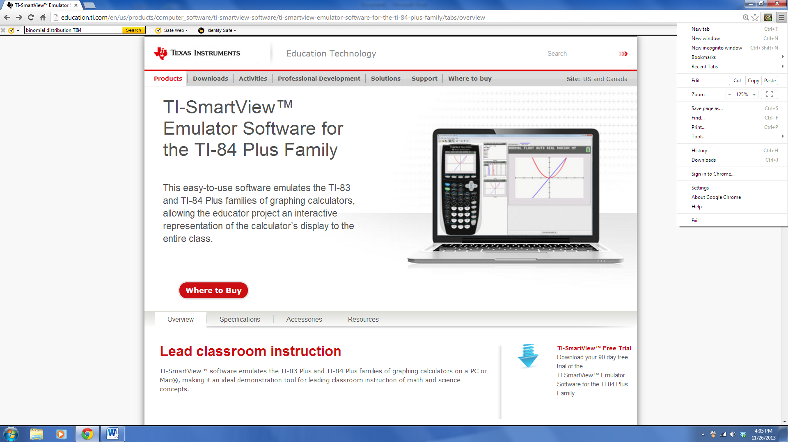

Click here

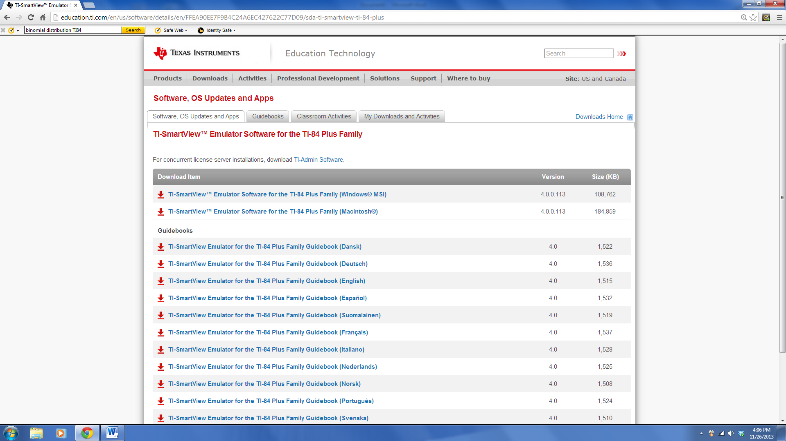

Choose Mac or PC to

Down load. Follow instruction on the screen